Lesson 10 – Activity Sheet

Getting Started
The micro:bit can use acceleration to sense various gestures or movements, such as up, down, left, right, face up, face down, freefall, 3g, 6g, 8g and shakes. We can use Python code to identify which gesture has been made using the line gesture = accelerometer.current_gesture()

Adapt the program below so that the micro:bit displays a left arrow when it is tilted to the left and a right arrow when it is tilted to the right.
from microbit import *

while True:
gesture = accelerometer.current_gesture()
if gesture == " ":
display.show(Image.REPLACE WITH YOURS)
else:
display.show(Image. REPLACE WITH YOURS)

Use an elif statement to add the right gesture. You can add more so that the micro:bit responds to being moved up and down too.
When testing the program using the emulator, select the appropriate gesture from the drop down box:

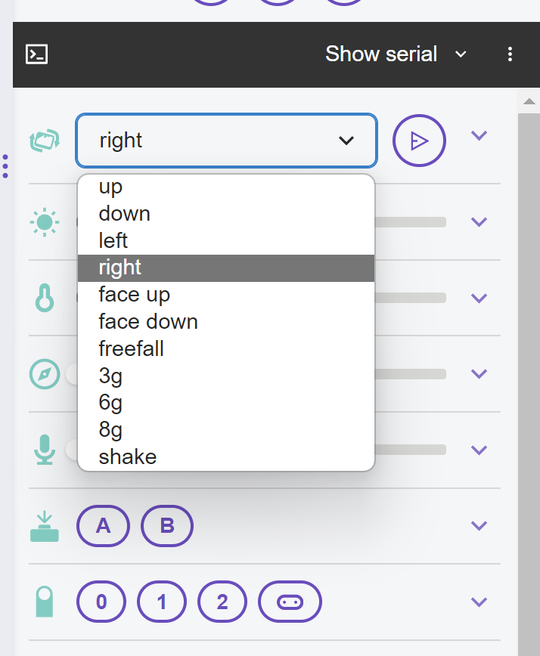

Build a Fortune Telling Machine
You are now going to make a fortune telling machine. Ask your micro:bit, the fortune telling machine, a question and then shake it. The answer to your question will be displayed on the LEDs. Copy out the starter program below
from microbit import *
import random

Notice that we are using the random module from Lesson 7 to select a random item from the answer list. We create out list by declaring a variable and then creating a list of items.

answers = ["Yes", "No", "I cannot answer that yet"]

Now we use a loop to keep the program running and display a question mark, then the micro:bit checks for the ‘shake’ gesture. If you shake your micro:bit then the display is cleared, there is a pause for one second and then the answer to your question is displayed.

while True:
display.show("?")
if accelerometer.was_gesture("shake"):
display.clear()
sleep(1000)
display.scroll(random.choice(answers))

Success Criteria
- Create the program with three responses
- Add additional responses to the answer list
- Create a fortune teller that responds in a believable way, with realistic responses

Pro-tip
Change what the fortune teller machine displays at the start by replacing the ? in the line display.show("?") with your own text.
Don’t forget the commas after each item in the answers list. If you miss them out this will cause an error and the program will not work.

Test Time
Download the code and try it out. Get another learner to ask your micro:bit question and then see what the responses are. Don’t forget to add additional responses to make the fortune tell seem more realistic.

Stretch Tasks
- Add additional answers to the answer list to create more variety
- Add a music response to the selection so that the fortune teller responds with a sound or melody
- Use elif statements to add other responses such as up or down which the fortune teller responds to

Final Thoughts
In this project we have covered gestures and movements and looked at how acceleration can be used to recognise particular gestures such as up, down, right and shake. We have also made use of the random module, lists and selection.
Think about how you could use gestures and code to improve your bike crash project from the previous lesson.

